ATM Locator design and specification

Design

Overview

This component will be used to list all ING ATM’s so as allow user to specify a Dutch city to bring a short list of ATM’s, to do that, this component will retrieve ATM’s list from ING REST service locator for ATM’s at https://www.ing.nl/api/locator/atms/ returning a JSON string, then provide a page listing it all and provide search by city capability.

In the page list, show all fields available from ING list and use the GeoLocation to show the selected ATM/Address at GoogleMaps page (not the GoogleMaps API)

Design Patterns

Spring MVC pattern, Spring REST pattern, JSON pattern, AngularJS framework, Spring Security, Log4j standard implementation

Industry Standards
    - Java 1.8
    - Spring webmvc 4.3
    - Spring Security 4.2
    - Jackson-core databind 2.7.5
    - Org.JSON
    - Maven project 4.0
    - Junit4
    - AngularJS/jQuery
    - Log4j

Required Algorithms

The Spring webmvc pattern will provide the standard package structure and we add more to it
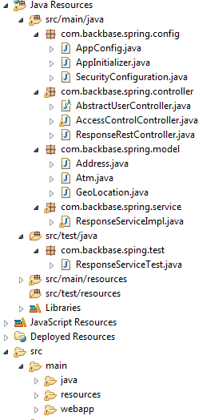

    - Class definition to be set according to the above package design,
      - AppConfig.java – class to setup the Spring MVC container,
The follow methods are to be define:
- viewResolver() – used for component scan at view level
- configureDefaultServletHandling(DefaultServletHandlerConfigurer configurer) – must be override to enable the configure.

1.4.2.2.AppInitializer.java – class to setup the Spring MVC container without need of web.xml,
The follow methods are to be define:
- onStartup(ServletContext container) – used to initialize the servlet dispatcher, this will map all context and allow viewResolver() to detect the view to be used.
- getServletMappings() – need to be override to allow REST request to the context.
1.4.2.3.SecurityConfiguration.java – Spring Security configuration class, used to define users, passwords, role privileges, grant/revoke permission by context/user,
The follow methods are to be define:
- configureGlobalSecurity() – Set users, passwords and roles
- configure() – Override method to override permission,

1.4.2.4.AbstractUserController.java – Abstract class to get spring security authentication information,
The follow methods are to be define:
- accessDeniedPage() – Redirect to accessDenied page when user is not authorized
- index() – Redirect to the main application when the user has permission,

1.4.2.5.AccessControlController.java – View controller to redirect spring security context
The follow methods are to be define:
- getPrincipal () – get the current login user

1.4.2.6.ResponseRestController.java – Spring REST component, will redirect all call to the listed contexts as a REST API call to the application : /list and /search/city/{city}
The follow methods are to be define:
- getList() – method to retrieve a list of all Dutch ATM’s,
- getSearch(@PathVariable("city") String city) – method to retrieve a list of ATM’s from a given city,

1.4.2.7.Atm.java, Address.java and GeoLocation.java – this are the model classes to represent one single ATM record extracted from the ING JSON response, the json looks as follow and will feed the classes during the load:
{
type: "ING",
address: {
street: "De Loper",
housenumber: "85",
postalcode: "3137 DD",
city: "Vlaardingen",
geoLocation: {
lat: "51.931701",
lng: "4.346158"
}
}
}

1.4.2.8. ResponseServiceImpl.java – Implementation Class component, will define all methods used to retrieve the ING JSON, fix bad JSON format provided by ING JSON, load the Atm obejcts, return list object to the Spring REST controller requests,
The follow methods are to be define:
- readAll(Reader rd) – receive the stream reader within the JSON, read it and return a JSON String,
- retrieveAtmsFromUrl(String url) - retrieve the ING JSON from the provided URL ex.: https://www.ing.nl/api/locator/atms/
- fixJsonText(String JSON) – fix possible broken json
- retrieveATMs(HashMap<String,String> filter) – method receive list of param to filter by city or bring all ATM’s, then build a list of Atm objects within Address data and GeoLocation data, and return this list to the view requester by the REST call,
- getATMsByCity(String city) – call retrieveATMs() passing the city as filter, this method is called by the REST component,
- getATMs() – call retrieveATMs() passing “all” as filter, bring all ATM’s and return to the REST component,

Container Diagram
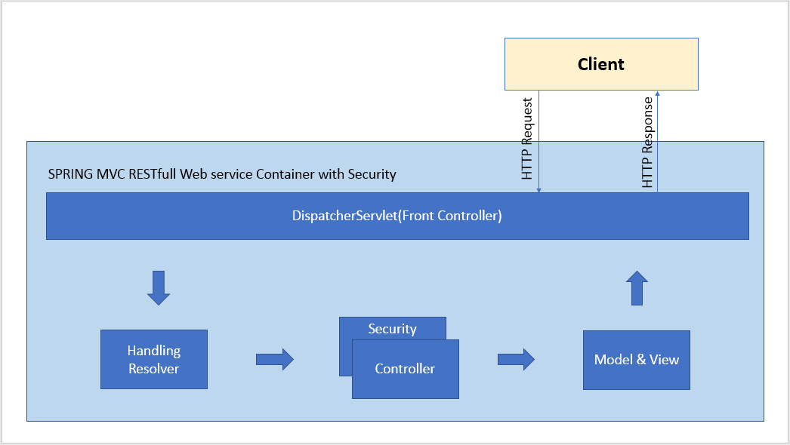

Component Specification
- Spring MVC
- Spring REST
- Spring Security
- AngularJS

Logging
This system can use Log4J as logging framework.

Log action
Every application (such as received http request, response and REST service) should be logged using log4j.

Mockups

1.8.1. Login page – Customize Spring-security login page login.jsp.
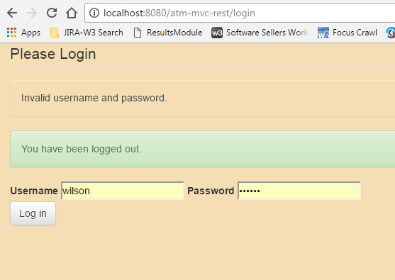

1.8.2. Search page – index.jsp, use this page to search for a city,

“Find ATMs” button, must have filled the city field,

“All ATMs” button, clean the city field and bring all ATM’s,

“Log out” button, call http://localhost:8080/atm-mvc-rest/login?logout to invalidate the signed user and get back to login page.

“get Maps” button, call Google maps passing street, city, postal code and GeoLocation lat/lgt, open a new Tab with Google maps location.
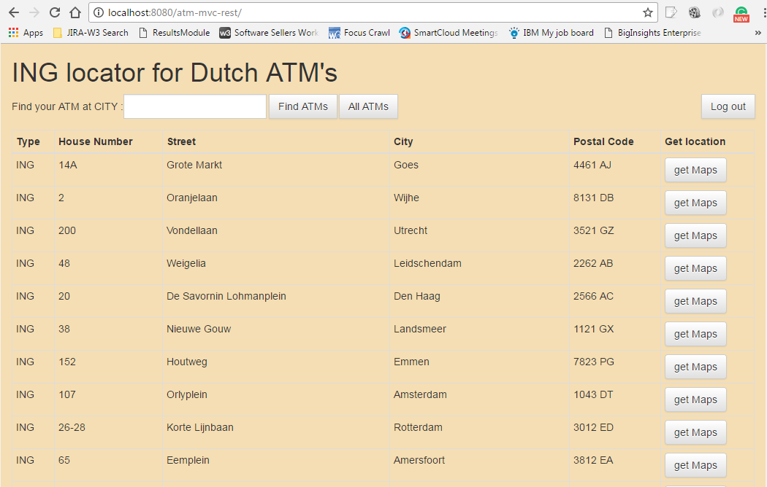

Environment Requirements

Environment
Java 1.8
Spring webmvc 4.3
Spring security 4.2
Jackson-core databind 2.7.5
Org.JSON
Maven project 4.0
Junit4
Log4j, Apache Commons Configuration

Installation and Configuration

Usage Notes

Required steps to test the component
Should be tested independently

Required steps to use the component
Install Tomcat 7.0.78
Maven 4

Demo

Future Enhancements
TBD.

Author: Wilson Mendonça da Penha Junior
Position: Software Architect
Date: 06/11/2017
Version: 1.0

